Project management coursework 

### PREPARED FOR

M30245

School of Computing

### PREPARED BY

UP942028

University of Portsmouth

# Task 1

### Project Planning and Deliverables Integration

Thorough project planning is crucial for guaranteeing that a project is finished on schedule, adheres to its defined scope, and utilises resources in an optimal manner. This task involves creating a Gantt chart that aligns with the project scope and critically assessing it with a well-reasoned justification. Furthermore, we will evaluate the staffing, organisational, and behavioural aspects of the project, utilising the **Behavioural Change Wheels** and the **RACI** chart to guarantee clear delineation of roles and responsibilities.

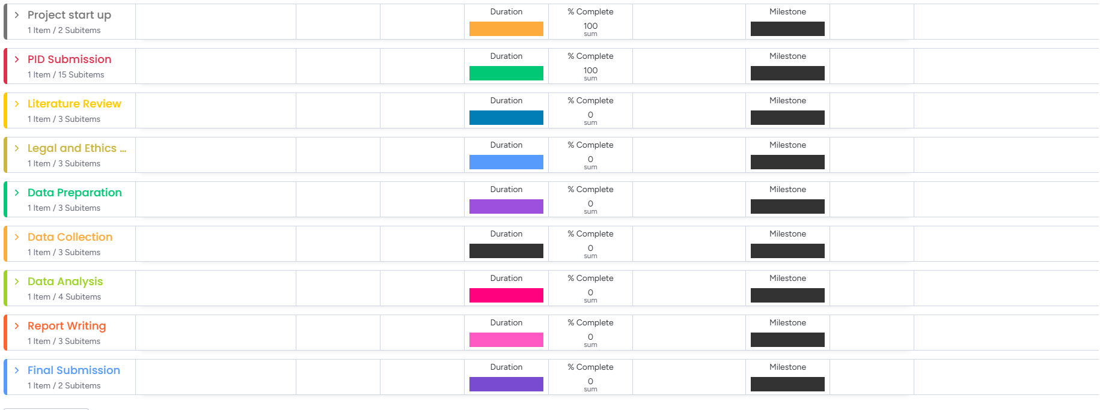

*Figure 1a: An overview of the Gantt chart table*

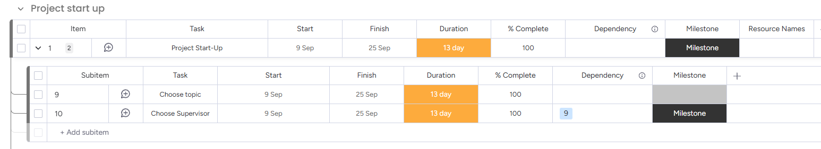

*Figure 1b: a representation of a group*

### Introduction

In project management, it is crucial to develop a well-organised plan that details the duties, roles, and timelines to ensure the project's successful completion. Incorporating tools such as Gantt charts as well as RACI charts is essential for effective planning in this process. This report examines the application of these tools within the project framework, highlighting a Gantt chart utilised over tracking tasks as well as a RACI chart designed for role assignment. The Gantt chart delineates the comprehensive project timeline into specific subtasks, emphasising essential dependencies and the order of tasks (Axelos, 2017). The RACI chart serves to delineate responsibilities, providing clarity for each team member regarding their particular position (Hughes & Cotterell, 2009). This report delves into the effects for handling resources, dependence, as well as human behaviour in facilitating the smooth execution of the project.

### Gantt Chart Overview and Critical Justification

The Gantt chart serves as an essential instrument over displaying the task timeline and comprehending the interdependencies among tasks. The Gantt chart (Figure 1c) illustrates the project's division into several phases, highlighting essential milestones and deadlines with clarity. This facilitates the monitoring of progress and guarantees adherence to deadlines. The Gantt chart was constructed by initially pinpointing the primary tasks of the project, subsequently breaking them down into sub tasks (e.g., task 1.1, 1.2), and at last establishing the dependencies among them (Axelos, 2017). The subtasks facilitate a logical progression of the project, ensuring that no tasks commence until their prerequisite tasks have been successfully completed.

Every sub-task within the Gantt chart was meticulously aligned with designated timeframes, facilitating precise scheduling. Dependencies were established among tasks to guarantee that the project remains on schedule (Hughes & Cotterell, 2009). The successful conclusion of "Task A" serves as a prerequisite for initiating "Task B", thereby ensuring that tasks are executed in the proper sequence to prevent any bottlenecks or delays. The Gantt chart also highlights these dependencies to indicate any potential delays that may impact additional duties (Axelos, 2017). This method is consistent with the principles laid out in Chapter 9 of Axelos (2017), which emphasises the use of product-based planning to decompose intricate tasks into more manageable elements.

Utilising the Gantt chart allowed me to set realistic task deadlines while also considering potential delays. Hughes & Cotterell (2009) emphasise that effective project planning requires not just the identification of tasks, but also an awareness of their interdependencies, which is crucial for a thorough understanding of the project's progression.

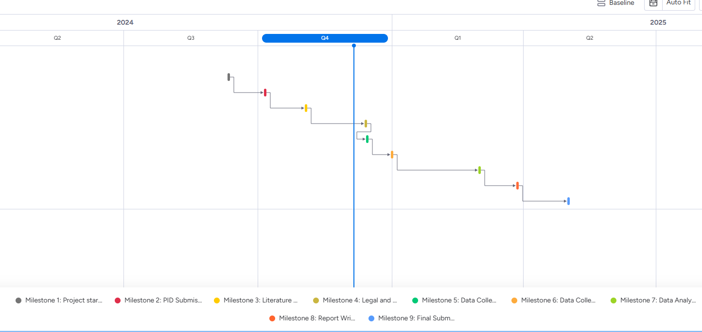

*Figure 1c: Gantt chart showing the project timeline, milestones, and dependencies.*

### RACI Chart and Resource Management

The RACI chart serves as an essential instrument for delineating roles and responsibilities throughout the project. Figure 2 (RACI Chart) illustrates the assignment of each key task to specific individuals, clearly delineating who is responsible, accountable, consulted, and informed for each subtask. The distinct allocation of responsibilities eliminates ambiguity and guarantees that each task is handled effectively (Hughes & Cotterell, 2009).

The RACI chart complements the Gantt chart by clearly delineating the individuals accountable for each task within the timeline. For example, in the Gantt chart, Task A and Task B have specific owners assigned, with their responsibilities detailed in the RACI chart (Axelos, 2017). This mapping guarantees that every task receives attention and that each team member is clear about their responsibilities within the project.

Furthermore, the RACI chart aids in effectively managing resource allocation by ensuring that the appropriate individuals are present at the necessary times. The RACI chart, in conjunction with the Gantt chart's timeline, facilitates effective resource management by aligning roles and responsibilities with the various phases of the project. Hughes & Cotterell (2009) assert that assigning clear responsibilities enhances coordination and results in a more seamless workflow across the project.

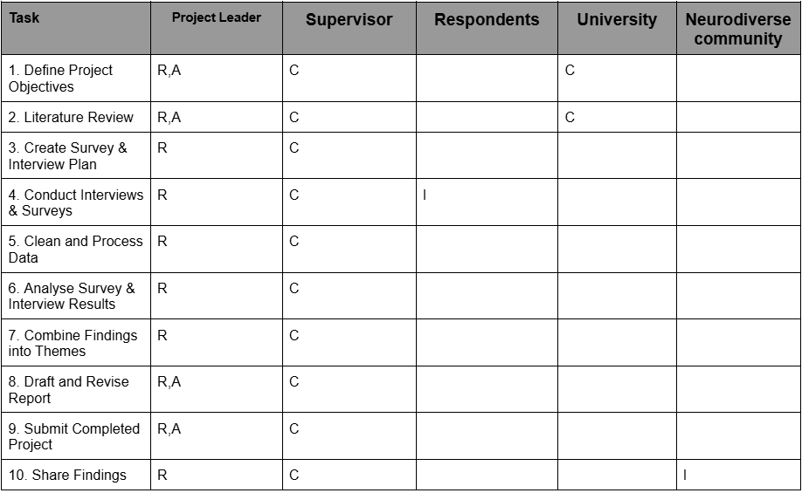

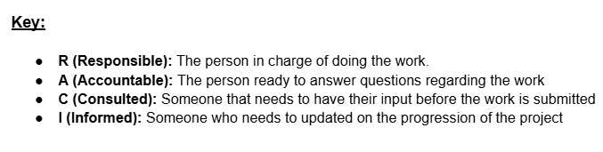

*Figure 2: RACI chart detailing the responsibilities of team members across project tasks and the key*

The RACI chart plays a crucial role in highlighting human resource implications, enabling project managers to swiftly pinpoint bottlenecks or identify areas that may require further support. According to Axelos (2017), successful project planning typically involves utilising tools that facilitate duty assignment and workload allocation, thereby ensuring that human resources are effectively allocated to meet deadlines.

### HR, Organisational, and Behavioural Implications

In any project, effectively managing human resources and grasping the intricacies of organisational dynamics are essential for achieving success. This project utilised a RACI chart to effectively delineate responsibilities, thereby reducing potential disputes by ensuring that each team member is aware of their specific role (Hughes & Cotterell, 2009). However, in addition to merely assigning tasks, it is crucial to take into account the behavioural dynamics of the team. As noted by Axelos (2017), utilising tools such as Gantt and RACI charts effectively can enhance the management of human behaviour by clarifying expectations, thereby minimising misunderstandings or miscommunications.

A notable challenge I anticipate is the possible resistance to change, as highlighted by the Behavioural Change Wheel structure (Michie et al., 2014). For instance, stakeholders might oppose specific alterations in the project framework. To address this, I intend to employ both Gantt and RACI charts to convey these changes clearly. By ensuring that all parties are well-informed and to account, these tools effectively reduce resistance and foster a more collaborative team environment.

Moreover, taking into account human factors such as team enthusiasm, the RACI chart can identify areas where further training or support may be required to align everyone with the project objectives. The Gantt chart serves as a valuable tool in this context, ensuring that deadlines remain manageable, thereby minimising the risk of burnout and enhancing overall project results (Hughes & Cotterell, 2009).

In summary, the implementation of the Gantt chart and RACI chart has demonstrated significant value in the planning, management, and execution of the project. These tools have significantly enhanced resource allocation and have provided clarity for team members regarding what they have to do. The Gantt chart, featuring a clear breakdown of tasks and their dependencies (Figure 1), along with the RACI chart (Figure 2) that outlines role allocation, plays a crucial role in keeping the project on track. Through a thorough understanding and application of these tools, I am assured that the project will progress seamlessly, adhering to its timelines and resource needs.

### 

# Task 2

Agile methodologies have become a crucial strategy in project management, especially for projects that demand iterative development and adaptability (Highsmith, 2009). This section examines the implementation of Agile methodologies in this project, focussing on the utilisation of a Kanban board (Figures A & B) and comparing it to the waterfall approach applied in Task 1. This analysis highlights Agile's flexibility and its congruence with the ever-changing landscape of research projects, bolstered by relevant literature references and accompanying screenshots.

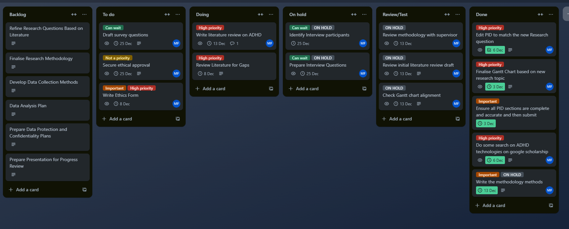

Figure 1a: an Overview of the Kanban board

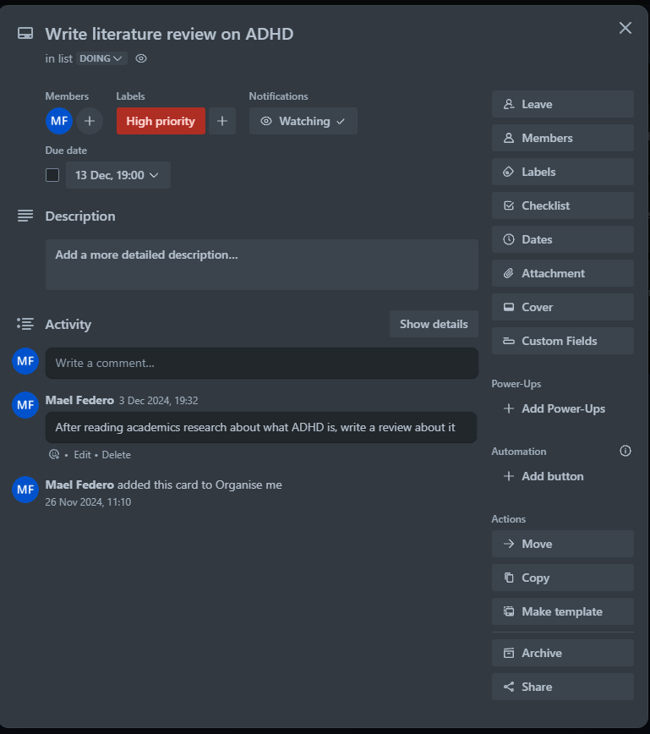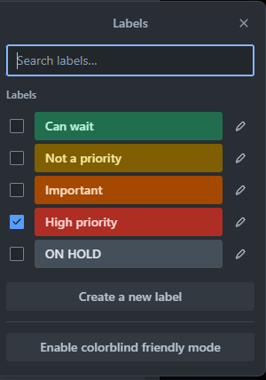

Figure 1b : A view of an actual ‘tasks’ with comments and a view of the label tab**Agile vs. Waterfall Methodologies**

In Task 1, the project planning phase was primarily guided by a **waterfal**l methodology, which is marked by a linear and sequential progression of tasks. Every phase?literature review, methodology development, and so forth?was contingent upon the successful completion of the prior phase. This structure is optimal for projects with well-defined requirements; however, it is not as effective in situations where objectives are subject to change or require iterative feedback, as demonstrated in Task 2.

**Agile methodologies** prioritise adaptability and foster collaboration. They emphasise the importance of delivering value by focussing on continuous improvement and being responsive to change, as highlighted by Beck et al. (2001) in the Agile Manifesto. The iterative approach of Agile proved to be especially beneficial during this phase of the project, as the need for flexibility was essential in honing research questions and modifying data collection techniques in response to new insights.

**Utilising a Kanban Board for Effective Task Management**

#### **Kanban Board for Task Organisation**

The application of **Agile methodologies** was supported by the use of a **Kanban board** (Figures A & B). This tool enabled the team to dynamically visualise and manage tasks across various stages: Backlog, To Do, Doing, On Hold, Review/Test, and Done. Every column illustrates the advancement of tasks, consistent with Agile principles that promote clear workflows and minimised bottlenecks (Kniberg, 2011).

* **Backlog:**Tasks including "Refine Research Questions Based on Literature" and "Develop Data Collection Methods" (Figure A) have been placed in the Backlog column. This facilitated a prioritisation process that effectively managed active task lists without causing overwhelm. The backlog reflects Agile's focus on keeping a collection of tasks that can be revisited according to the project's requirements.
* **To Do and Doing:**The "To Do" and “ Doing” columns included actionable items such as draughting survey questions and obtaining ethical approval. In the meantime, high-priority tasks, including the writing of the ethics form, were shifted to the "Doing" column, highlighted with red labels to signify their urgency (Figure A). This labelling system guaranteed that essential tasks for project success were not missed, exemplifying a best practice in Agile project management (Hoda, Noble, & Marshall, 2011).
* **Review/Test and Done:**Tasks such as "Finalise Gantt Chart" (Figure B) have been successfully moved to the Done column, clearly showcasing the progress made. The "Review/Test" column encompassed tasks such as discussing the methodology with a supervisor, reflecting Agile’s focus on consistent reviews and quality assurance. This iterative review cycle facilitated ongoing enhancement and guaranteed that deliverables aligned with the project's changing requirements.

#### **Agile Features in the Current Implementation**

1. **Task Prioritisation and Labelling:**Using labels such as "High Priority" and "Can Wait" (Figures A & B)allows the team of workers to allocate resources effectively and address tasks in order of importance. Agile methodologies stress the need for clear prioritisation to ensure that value is delivered incrementally throughout the project (Highsmith, 2009).
2. **Iteration and Feedback Loops:**Tasks in the "On Hold" column, like identifying interview participants, were reassessed in light of advancements in related areas, showcasing the iterative nature of Agile methodology. The ability to pause tasks and modify timelines in response to evolving needs signifies a shift away from the strict structure of the waterfall methodology in Task 1.
3. **Collaboration and Communication:**The comments on the cards, like “After reviewing academic research on ADHD, please write a review?” offered clarity and ensured alignment among all team members. Agile fosters collaboration by enhancing shared understanding, a quality made possible through the transparency and commenting features of the Kanban board.
4. **Flexibility in Planning:**In contrast to the Gantt chart utilised in Task 1, which imposed a rigid sequence of tasks, the Kanban board facilitated a more flexible approach, enabling the dynamic reordering and reallocation of tasks. For instance, tasks like "Prepare Data Protection and Confidentiality Plans" in the Backlog may be reprioritised according to the results of ethical reviews, reflecting Agile’s inherent adaptability to change.

#### **Challenges and Mitigation**

Agile provides notable benefits, yet it also introduces certain challenges. For example, overseeing the dependencies between tasks, like ensuring the literature review is completed prior to refining research questions, necessitated meticulous attention. The team implemented regular reviews and alignment checks to tackle this issue, as illustrated in the "Review/Test" column (Figure A). Furthermore, implementing clear deadlines and labels effectively reduced the likelihood of tasks becoming stagnant in the backlog or remaining on hold.

#### **Analysis on Agile’s Effectiveness**

The use of Agile methodologies in Task 2 demonstrated its effectiveness for research projects that have changing goals. Through iterative refinement and prioritisation, Agile kept the project aligned with its objectives, adapting seamlessly as new insights surfaced. In contrast to the waterfall approach of Task 1, Agile offered a more adaptable and cooperative framework, which proved especially beneficial for handling tasks that had overlapping timelines and interdependencies.

Kniberg (2011) and Highsmith (2009) highlight that Agile is not a universal solution; rather, it achieves its greatest effectiveness when customised to meet the unique requirements of a project. The adaptability in this scenario enhanced the structured planning of Task 1, resulting in a comprehensive approach to project management that harmonised predictability with flexibility.

#### **Conclusion**

The shift from a waterfall methodology in Task 1 for Agile methodologies in Task 2 highlights the significance of choosing the appropriate project management strategy according to the specific context. The Gantt chart and RACI matrix in Task 1 established a robust framework for planning, while the Kanban board and Agile principles in Task 2 introduced the necessary adaptability to address the uncertainties that are intrinsic to research projects. This cohesive strategy guaranteed that the project stayed aligned with its goals, providing value throughout each phase.

# Task 3

**Reflective Logbook Weekly Entry Sheet**

| **Week number: 6**  **Nature of the learning activity**  *Briefly describe the learning activity: for example undertaking a reading preparatory task, attending a lecture/seminar, or presenting a report to a management team:*  Week 6, was about soft skills, we went over some sort of project given by the council of Portsmouth City, asking us to demonstrate the use of soft skill within a group, their importance, how to evaluate these soft skills within a team in order for the team to grow as a Unity and deliver project based on their requirements and ensure the success of these projects.  State how many hours this took: 4 |
| --- |
| **DESCRIPTION OF THE LEARNING ACTIVITY** |
| D – Describe objectively what happened  *Give the details of what happened. Answer the question: ‘What did I do, read, see, and hear?’ Describe how this opportunity came about; where, when and how you did the learning activity, the type of learning activity and what you hoped to gain from it.*  We’ve gotten into groups, and researched soft skills, we’ve had to understand the meaning of soft skills, what soft skills are, and how soft skills are important in terms of project development |
| I – Interpret the events  *Explain your learning: new insights, connections with other learning, your feelings, hypotheses, and conclusions. Answer the questions: ‘What was the reason I did this activity?’ ‘What might it mean?’*  The reason we did this activity specifically would be for us to understand what soft skills are, where and how they are used, and how to ensure project growth, which is well assured through soft skills. What I mean by that is, it is important to analyse and evaluate every team member’s soft skills, so people like the scrum master can predict any sort of conflicts that might come up later, and deal with it efficiently. |
| E – Evaluate what you learned  Make judgments connected to observations you have made. Answer the question: ‘How was this useful?’  This was very useful, because I never knew the importance of some soft skills for example, the soft skill “Punctuality” is important because without it, projects could potentially get delayed, and that wouldn’t be good for business, and could lead to losing customers |
| P – Plan how this learning will be applied  *Comment on its relevance to your course, programme, future profession, and life... Answer the question: ‘How might this learning apply in my future?*’  This week’s topic is very much relevant to my course, firstly because I’m a due to be Software Engineer, implying that I will be dealing with projects my whole life, and in order for those projects to be completed to the best of my abilities, I’m eventually going to have to review some of the soft skills I already have, try to improve on the ones that need improving, and also get to develop new soft skills in order for me to be as flexible and reliable as possible within the workplace. |

| **Week number: 4**  **Nature of the learning activity**  *Briefly describe the learning activity: for example undertaking a reading preparatory task, attending a lecture/seminar, or presenting a report to a management team:*  The nature of this event was a seminar that we had to attend, but also a lecture. The lecture provided us with more insights of what planning levels are, and to understand and be able to justify important concepts of project management and how they ‘integrate’ with Agile Methodologies.  State how many hours this took: 4 |
| --- |
| **DESCRIPTION OF THE LEARNING ACTIVITY** |
| D – Describe objectively what happened  *Give the details of what happened. Answer the question: ‘What did I do, read, see, and hear?’ Describe how this opportunity came about; where, when and how you did the learning activity, the type of learning activity and what you hoped to gain from it.*  The objective of this learning activity was to explain what planning is, it’s concept and to be able to distinguish between what is considered high-level and detailed planning, and also to describe the principles of product-based planning and it’s integration with software development methods |
| I – Interpret the events  *Explain your learning: new insights, connections with other learning, your feelings, hypotheses, and conclusions. Answer the questions: ‘What was the reason I did this activity?’ ‘What might it mean?’*  The way I interpreted this event, it felt like it was about introducing us to product breakdown structure, product flow diagrams, and work breakdown structure. This week’s event also taught us more insights in terms of Gantt charts, and allocating resources techniques. |
| E – Evaluate what you learned  Make judgments connected to observations you have made. Answer the question: ‘How was this useful?’  It was useful because the events highlighted the importance of planning, the distinction between high-level and detailed planning, and the three stages of a product-based planning: product breakdown structure, product flow diagram, and work breakdown structure. This event taught us to be specific and accurate as we move from high-level to low-level planning by using product breakdown structure for example. |
| P – Plan how this learning will be applied  *Comment on its relevance to your course, programme, future profession, and life... Answer the question: ‘How might this learning apply in my future?*’  This may apply to me in the future, because I could potentially see myself working into Project Management, where i’d be expected to know the key difference between Traditional methodologies and the agile ones, I’d have to be able to explain the difference between the different concepts of project management. |

| **Week number: 5**  **Nature of the learning activity**  *Briefly describe the learning activity: for example undertaking a reading preparatory task, attending a lecture/seminar, or presenting a report to a management team:*  State how many hours this took: 5 |
| --- |
| **DESCRIPTION OF THE LEARNING ACTIVITY** |
| D – Describe objectively what happened  *Give the details of what happened. Answer the question: ‘What did I do, read, see, and hear?’ Describe how this opportunity came about; where, when and how you did the learning activity, the type of learning activity and what you hoped to gain from it.*  Gotten to learn more insights about Agile methodologies. We learnt about the agile manifesto's four core values which priotise responding to change over following a plan, and where or how its principles can be applied in Software engineering through multiple methods such as Scrum, SafE, Xp, DSDM, Kanban |
| I – Interpret the events  *Explain your learning: new insights, connections with other learning, your feelings, hypotheses, and conclusions. Answer the questions: ‘What was the reason I did this activity?’ ‘What might it mean?’*  Learnt about the four core values of an Agile Manifesto, I’ve also been able to summarise them and describe the trade off that is often required for effective implementation  I learnt what DSDM was, ( a frame work) and how to utilise it |
| E – Evaluate what you learned  Make judgments connected to observations you have made. Answer the question: ‘How was this useful?’  This was quite useful, as I could implement it into my final year project in order to emphasise the success of that project. |
| P – Plan how this learning will be applied  *Comment on its relevance to your course, programme, future profession, and life... Answer the question: ‘How might this learning apply in my future?*’  It might apply to me in the future, because I could be positioned in a team where it is required to use an Agile methodology for a project manager, where I would need to understand the fundamentals of Agile methodology and where i’d require to apply the four core values of an Agile Manifesto’ |

# References

Axelos. (2017). *Managing Successful Projects with PRINCE2 (6th ed.)*. The Stationery Office.

Hughes, B., & Cotterell, M. (2009). *Software Project Management (5th ed.)*. McGraw-Hill.

Monday.com. (n.d.). *ADHD technology evaluation project Gantt chart* [Project management board]. Retrieved December 6, 2024, from<https://myport225377.monday.com/boards/1731091707> (Gantt chart)

Michie, S., van Stralen, M. M., & West, R. (2014). The Behavioural Change Wheel: A new method for characterising and designing behaviour change interventions. *Implementation Science, 9*, 1-12. <https://doi.org/10.1186/1748-5908-9-1>

Trello. (n.d.). *ADHD technology evaluation project* [Kanban board]. Retrieved December 6, 2024, from<https://trello.com/b/hvU7Xl8x/adhd-technology-evaluation-project> ( Kanban)

Beck, K., Beedle, M., van Bennekum, A., et al. (2001). **Manifesto for Agile Software Development**. Retrieved from<https://agilemanifesto.org>

Highsmith, J. (2009). *Agile Project Management: Creating Innovative Products*. Addison-Wesley.

Hoda, R., Noble, J., & Marshall, S. (2011). The impact of Agile practices on team collaboration and project performance. *Empirical Software Engineering*, 16(3), 281–305.

Kniberg, H. (2011). *Kanban and Scrum: Making the Most of Both*. C4Media.

Scholarcy. (n.d.). *Scholarcy article summariser* [Web application]. Retrieved from<https://scholarcy.com>

OpenAI. (2024). *ChatGPT (December 6 version)* [Large language model]. Retrieved from<https://chat.openai.com>

# Appendix

[Number your appendix e.g. Appendix 1, Appendix 2, etc.]